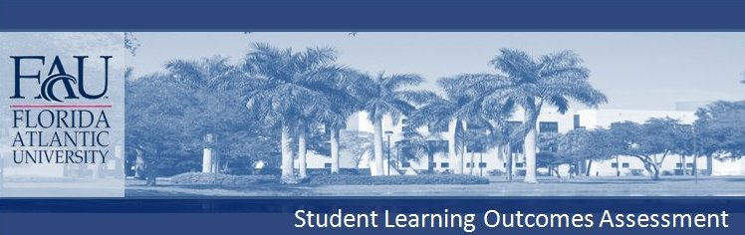
COLLEGE OF DESIGN AND SOCIAL INQUIRY
School of Public Administration
Bachelor of Public Satefy Administration

The Bachelor of Public Safety Administration (BPSA) program requires the following courses:

PAD 3003 Public Management and Administration
PAD 3104 Organizational Behavior and Administrative Communication
CCJ 3024 Criminal Justice Systems or SOW 4101 Human Behavior and Social Environment I
PAD 4604 Administrative Process and Ethics or CCJ 4054 Ethics and the Justice System
PAD 4332 Managing for Excellence in the Public and Nonprofit Sectors
SOW 4620 Minority Issues in Social Work
Plus 12 credits of public safety administration elective

CONTENT KNOWLEDGE (Declarative Knowledge): BPSA students will demonstrate that they have learned the theoretical frameworks, practical applications, and general terminology of public safety administration. Specifically, students will acquire knowledge about administrative structures, concepts of organizational behavior and administrative communication, criminal justice systems within the United States, human behavior and social environment, ethics and ethical reasoning.

CONTENT KNOWLEDGE (Technical Skills): BPSA students will demonstrate that they have learned the methods and strategies used to implement public safety policy.

COMMUNICATION (Written Communication; Oral Communication): BPSA students will produce written communications, such as research papers, issue assessments, and case studies that are grammatically correct and include a thesis statement, body and conclusion. Students will demonstrate effective oral communication skills by presenting a well‐ organized and well‐conceptualized oral presentation in the field of public safety.

CRITICAL THINKING (Analytical skills, Creative skills, Practical skills): Students will be able to raise vital questions and problems, gather and assess relevant information, generate
well‐reasoned solutions and conclusions, think open‐mindedly, and communicate effectively with others on issues and topics appropriate to the field of public management.

While enrolled in the program, all Bachelor of Public Safety Administration (BPSA) students’ learning outcomes are assessed on course base, via different measure approaches including exams, case analysis, and short essays. Students’ learning outcomes are also assessed at the end of the program via surveys.

